Product Design
Team | 57, Lip-sync Application, Arumulla Sri Ram, Harsha Pathuri, Revanth Madhavarapu, Thukkaraju Sai Sathwik Reddy

Design Overview

Architectural design
Login and Sign Up for the User-admin managed by AWS Cognito subsystem.
Audio module to select/record an audio clip.
Video module to select/record/upload video clip.
Lip-sync module to generate and save/share the lip-synced video.
Backend server to fetch data from AWS S3 and serve requests from the application.
Audio module is responsible for selecting audio clip. It fetches audio clips by making requests to the backend server.
Video module is responsible for selecting video clip. It fetches personas clips by making requests to the backend server.
Lip-sync module is responsible for generating lip-sync video from audio and video files selected in audio and video modules respectively.
The diagram below shows how the user can interact with the system. The blue boxes are pages that user visits and pink boxes are modules that are used to serve the purpose.
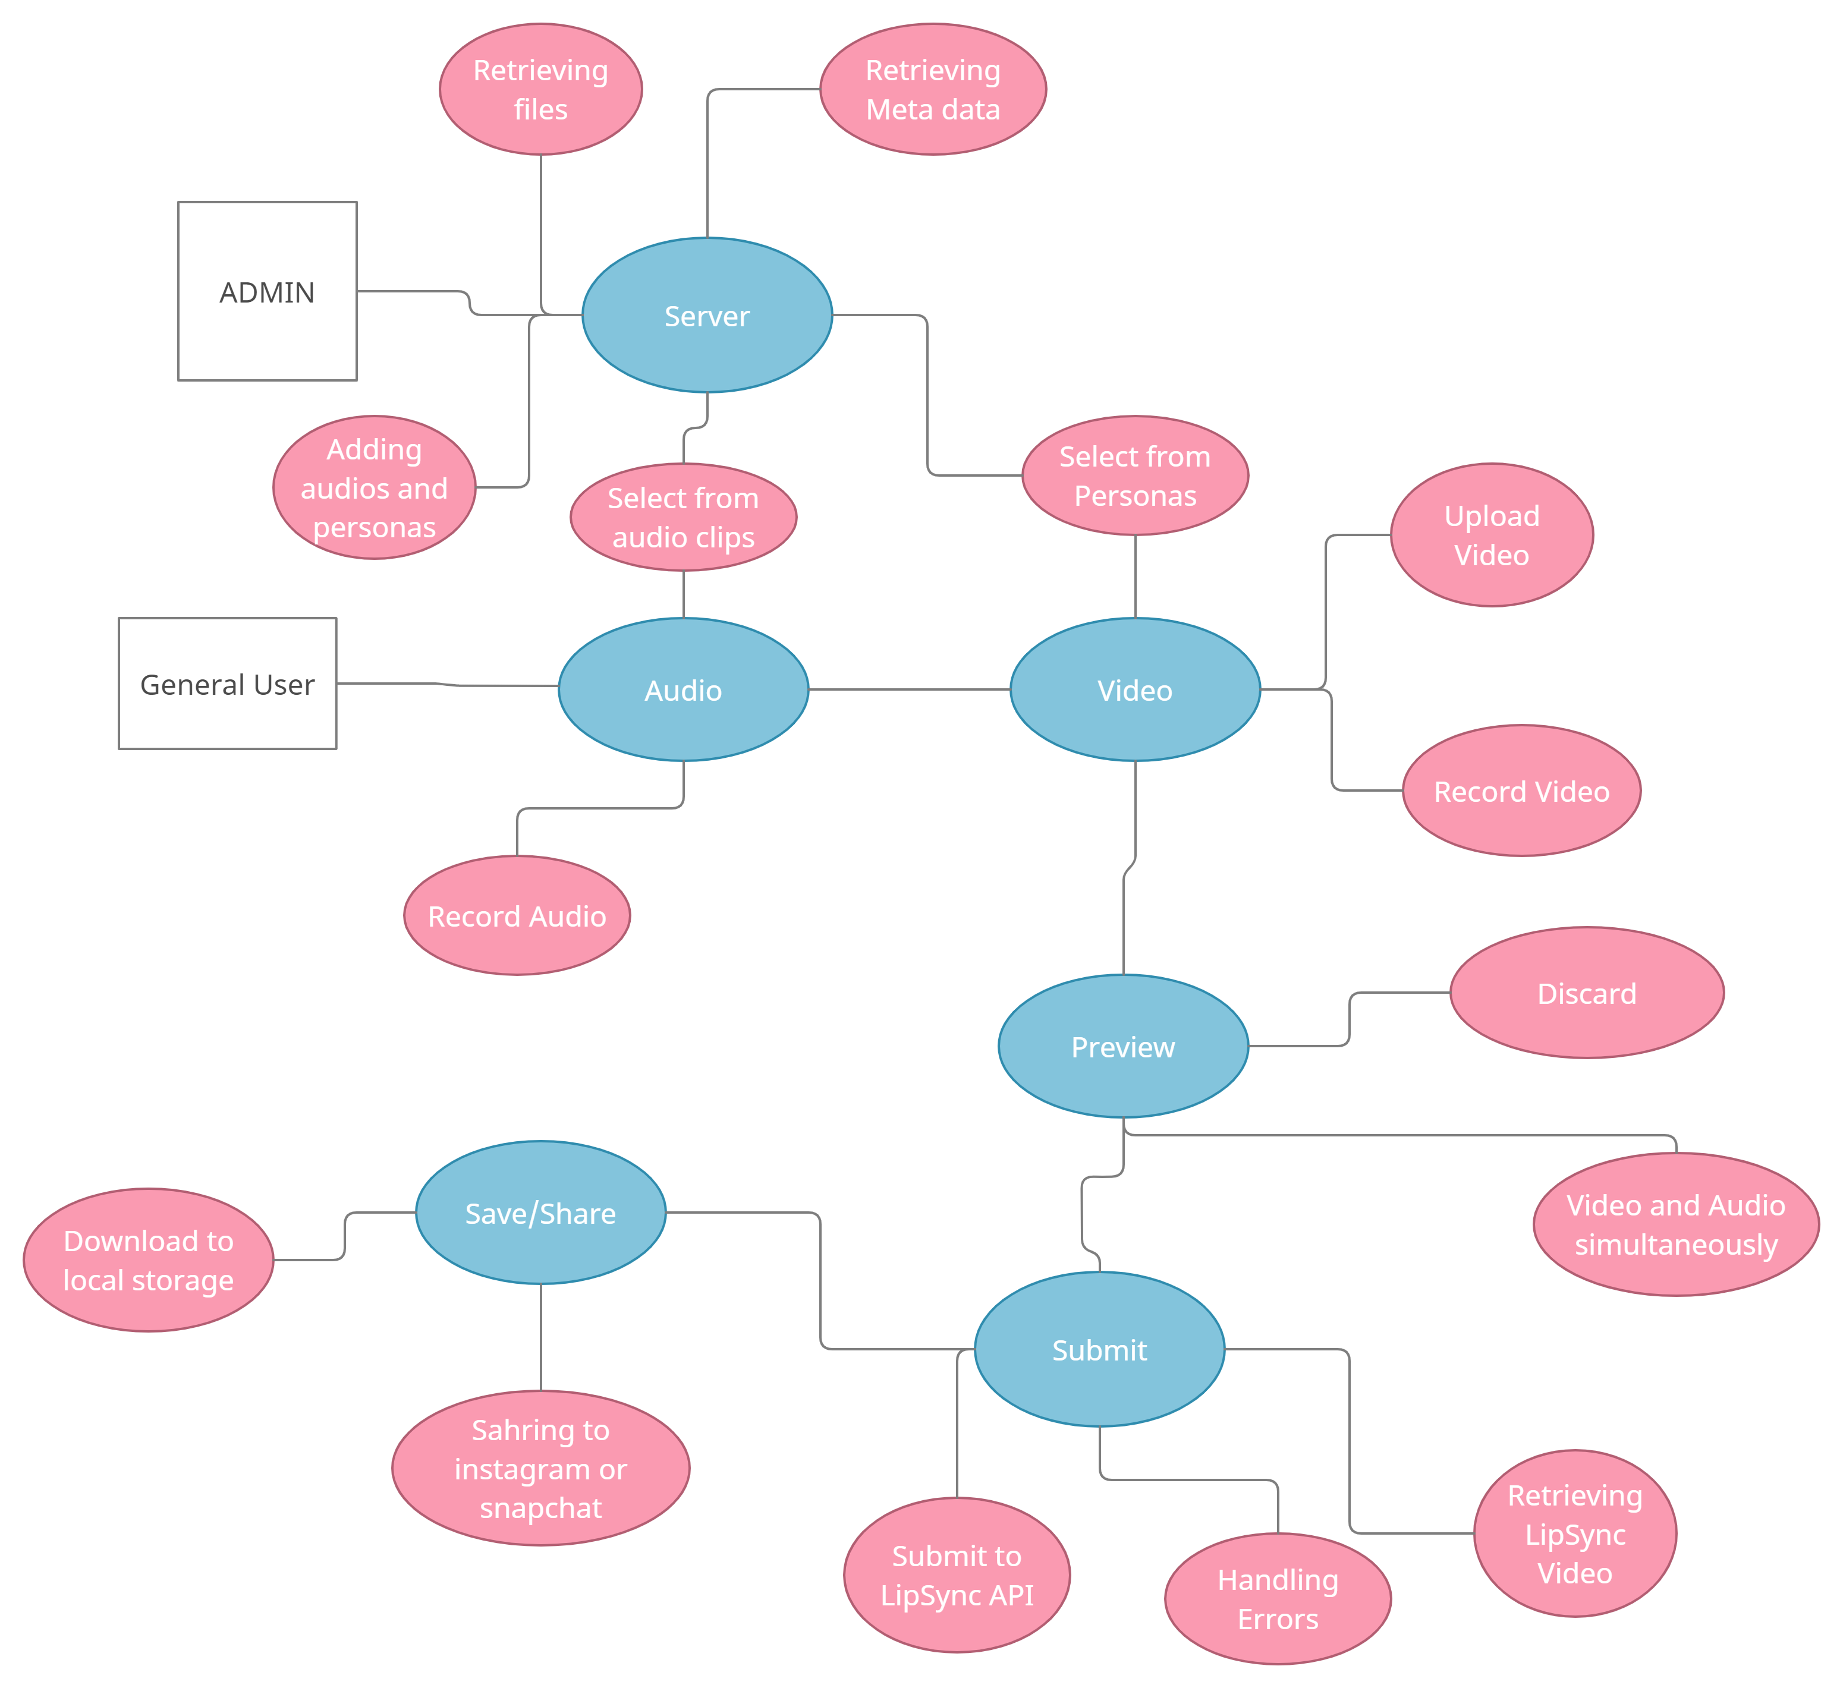

Use Case Diagram: 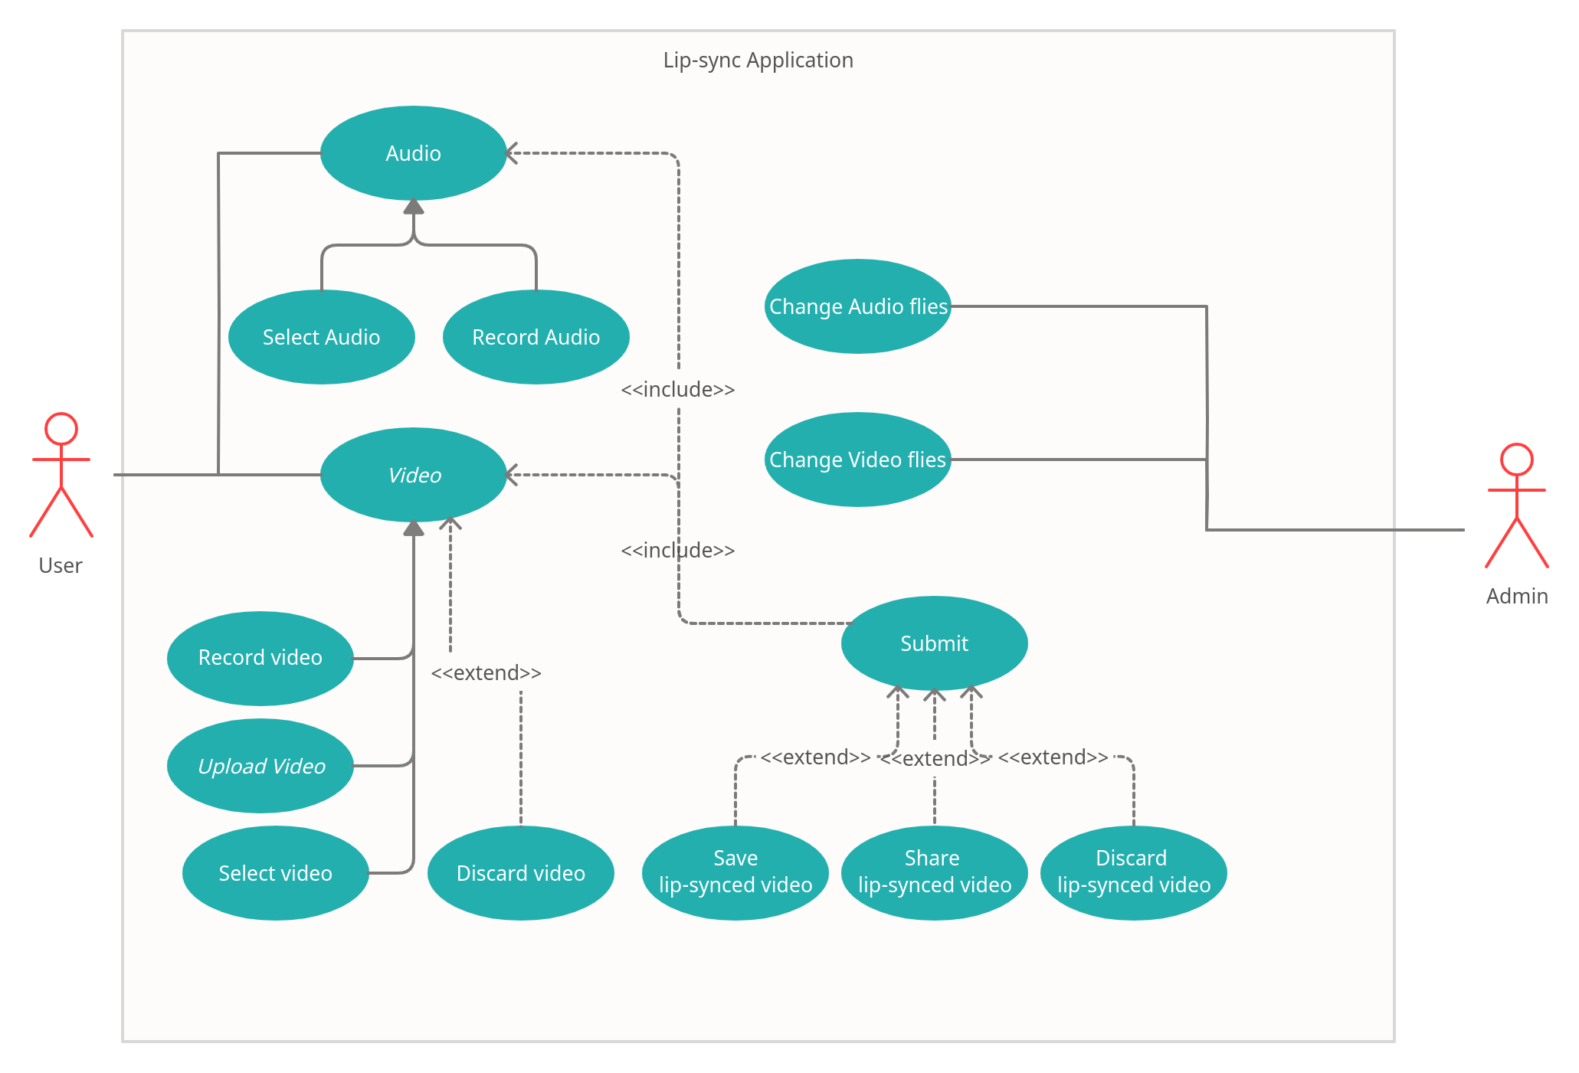

System interfaces

User Interface

Explain how the user will be able to use your system to complete all the expected features. Add screenshots if possible. If this is not applicable to your project, you may omit it.
General user:
- Initially the user must select an audio clip. User can do it in two ways.
  - Browse and select an audio clip provided inside the application. User can play audio clips before selecting.
  - Record an audio clip using an audio recorder inside the application. User can play recorded audio clip before confirming.
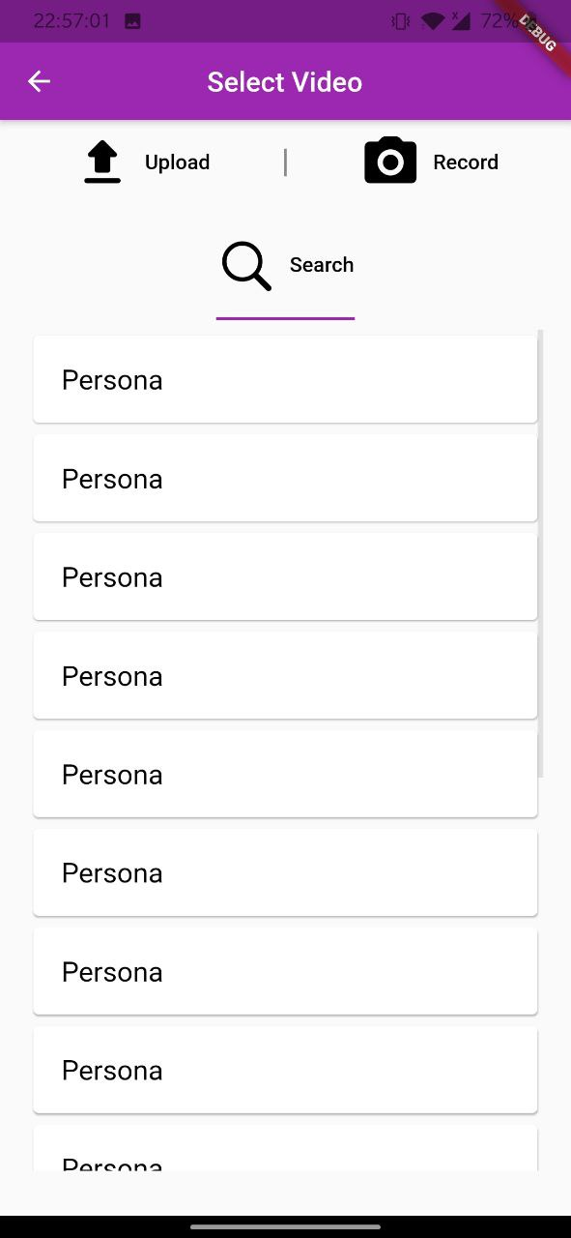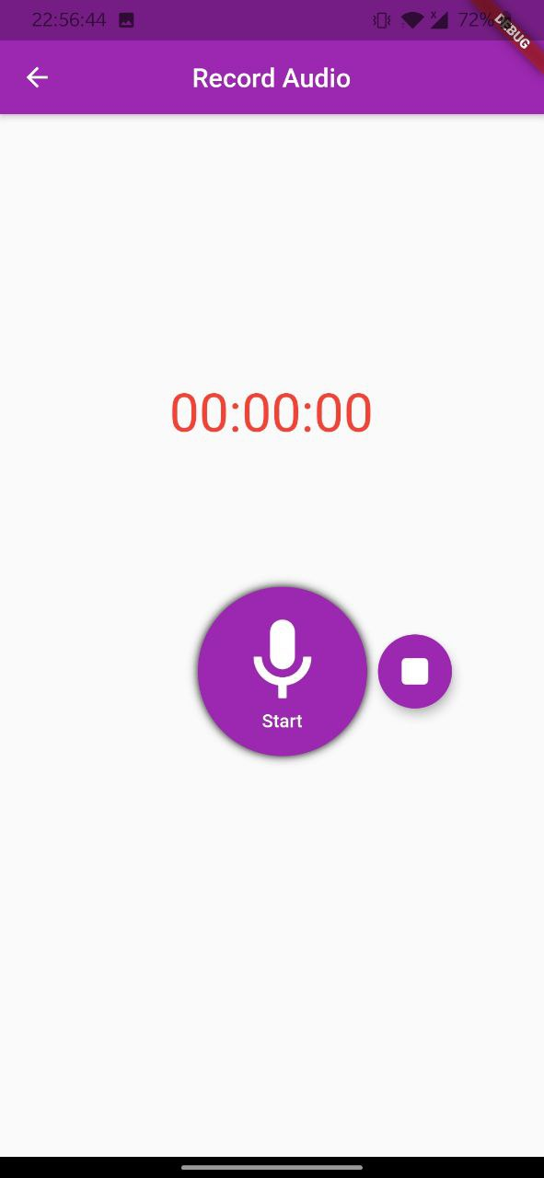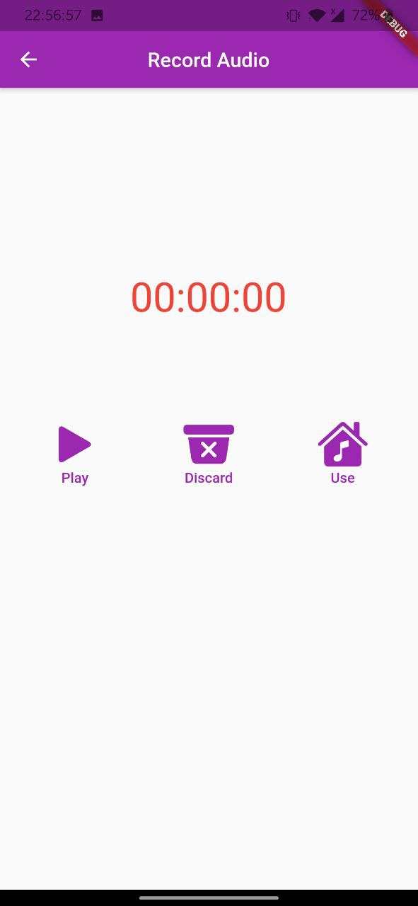
- After that the user selects a video clip. User can do it in three ways.
  - Browse and select a video clip provided inside the application.
  - Record a video for a maximum of 30 seconds.
  - Select a video clip from the device.
- After that, the user submits selected audio and video clips to generate lip-sync video. User can play both audio and video clips at the same time before submitting.
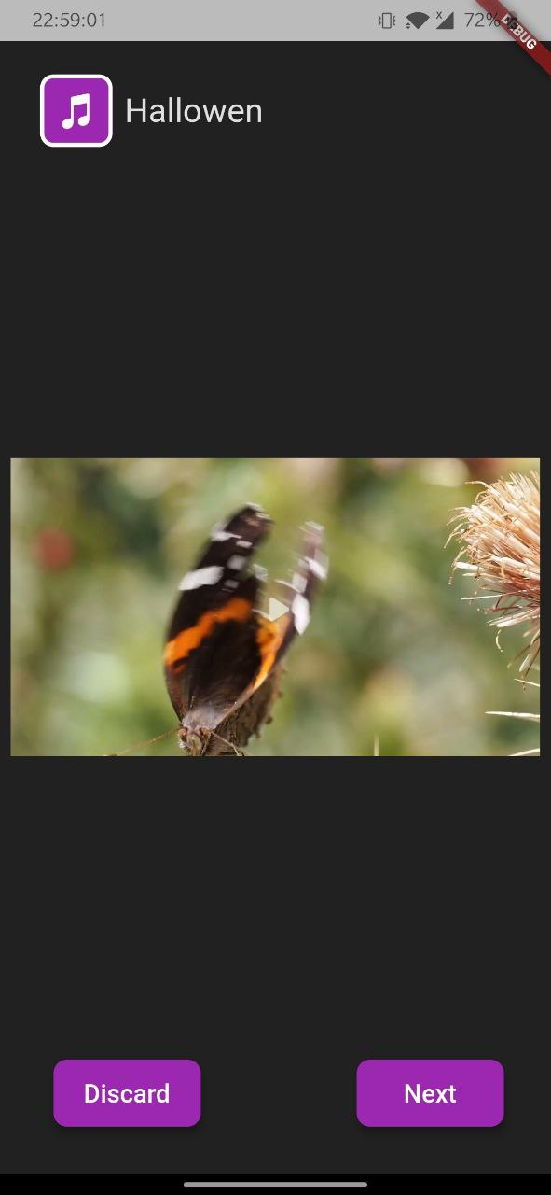
- After submitting, user gets a lip-synced video which can be viewed within the application. User can save the video to the device or can share it through other applications.
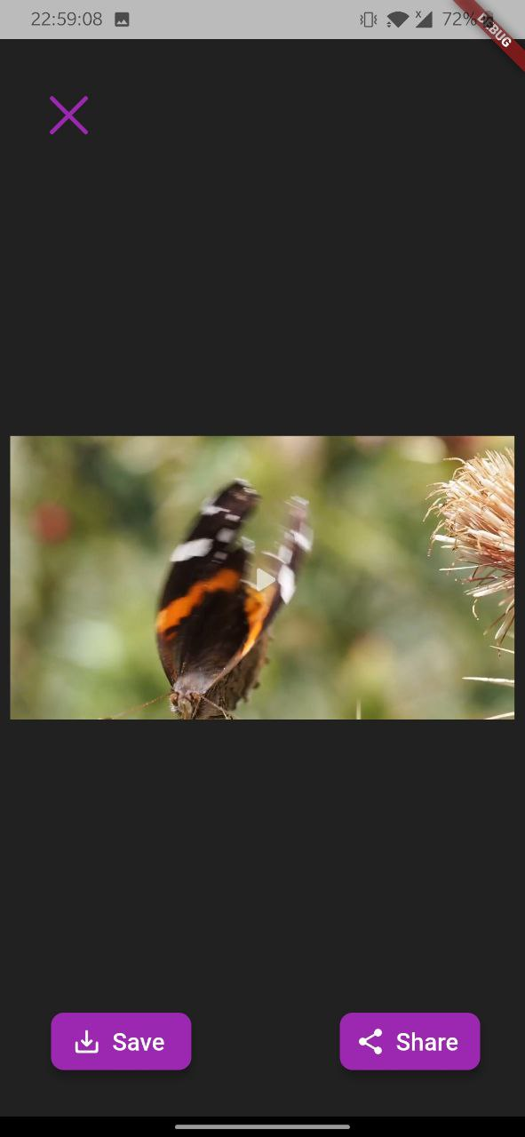
Admin:
- Admin will log in into the mobile app with his credentials.
- Admin can add audio clips, personas to the application which will be available to all general users.

APIs
- We will be exposing LipSync API provided by the client, to the user.
Description: Upload video and audio files and get the lip-synced video.
Endpoint: https://lipsync/api/
HTTP Method: POST
OAuth: Required
Possible Errors:
400 Bad Request - Required fields were invalid, not specified.
401 Unauthorized - Access token is invalid or has been revoked.

- We will expose self-built API for the mobile application to get information from databases and other sources.
    - Description: Upload personas, audio clips. or receive complete persona, audio clips.
Endpoint: localhost/uploadFile
HTTP Method: POST
OAuth: Required
Possible Errors:
400 Bad Request - Required fields were invalid, not specified.
401 Unauthorized - Access token is invalid or has been revoked.
b. Description: get metadata of audio clips and personas.
Endpoint: localhost/getMetaData
HTTP Method: POST
OAuth: Required
Possible Errors:
400 Bad Request - Required fields were invalid, not specified.
401 Unauthorized - Access token is invalid or has been revoked.
c. Description: Stream audio files or personas in mobile application.
Endpoint: localhost/getDownloadLink
HTTP Method: POST
OAuth: Required
Possible Errors:
400 Bad Request - Required fields were invalid, not specified.
401 Unauthorized - Access token is invalid or has been revoked.

Model
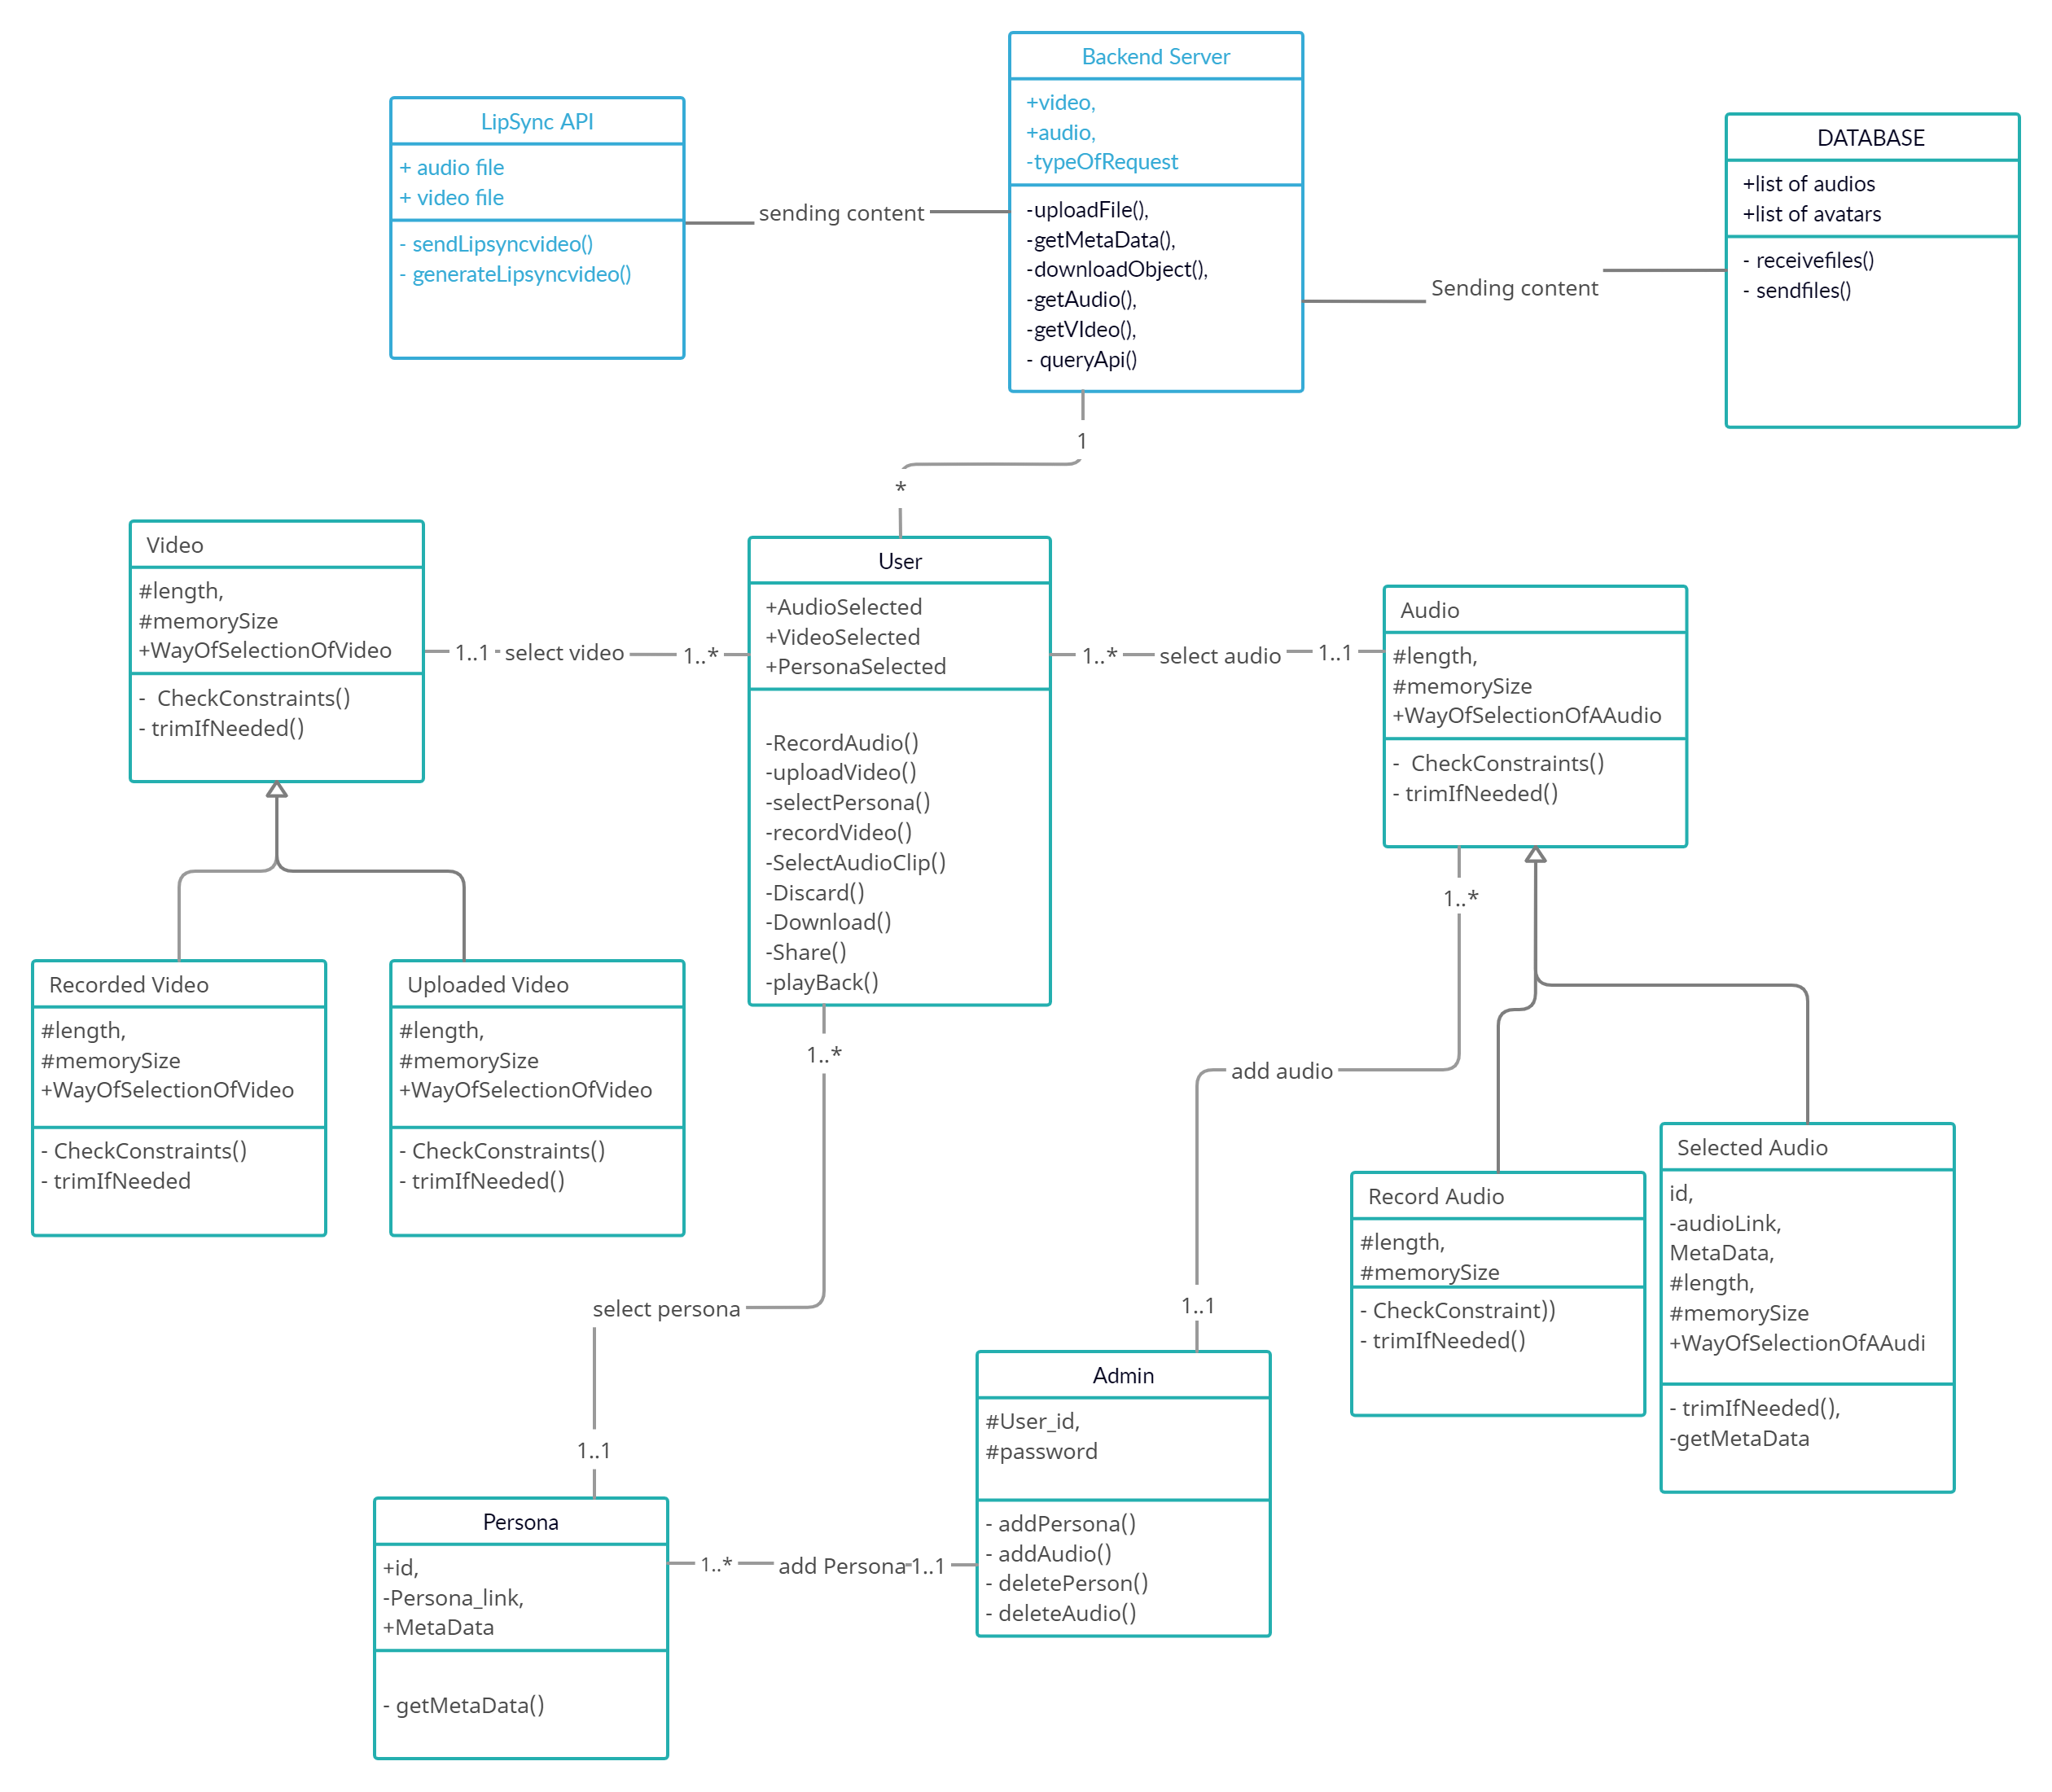
User | Class state  - The audio user selected for generating lip-sync video.  - Video/Persona user selected for generating lip-sync video.  Class behavior  - Record Video  - Upload Video  - Select Persona  - Record Video  - Select Audio Clip  - Discard the generated lip-sync video.  - Download the generated lip-sync video.  - Share the generated lip-sync video.  - Playback the generated lip-sync video.
Video | Class state  - Length of the video  - Memory size of the video  - The way(record/upload) in which video is selected for lip-sync.  Class behavior  - Checking if the video has valid constraints (size and length).  - Trim the video if needed.
Recorded Video | Class state  - Length of the video  - Memory size of the video  - The way(record/upload) in which video is selected for lip-sync.  Class behavior  - Checking if the video has valid constraints (size and length).  - Trim the video if needed.
Uploaded Video | Class state  - Length of the video  - Memory size of the video  - The way(record/upload) in which video is selected for lip-sync.  Class behavior  - Checking if the video has valid constraints (size and length).  - Trim the video if needed.
Audio | Class state  - Length of the video  - Memory size of the video  - The way(record/upload) in which video is selected for lip-sync.  Class behavior  - Checking if the video has valid constraints (size and length).  - Trim the audio if needed.
Recorded Audio | Class state  - Length of the video  - Memory size of the video  - The way(record/upload) in which video is selected for lip-sync.  Class behavior  - Checking if the video has valid constraints (size and length).  - Trim the audio if needed.
Selected Audio | Class state  - Length of the video  - A unique id  - Link for the audio  - Metadata  - Memory size of the video  - The way(record/upload) in which video is selected for lip-sync.  Class behavior  - Checking if the video has valid constraints (size and length).  - Trim the audio if needed.
Persona | Class state  - A unique id  - Link for the persona  - Metadata  Class behavior  - Getting a metadata.
Admin | Class state  - Unique user ID for admin  - Secure password  Class behavior  - Add persona/personas to the persona list.  - Add audio/audios to the audio list.  - Delete persona/personas to the persona list.  - Delete audio/audios to the audio list.
API | Class state  - Submitted audio file.  - Submitted video file.  Class behavior  - Generate lip-sync video.  - Send lip-sync video.  - Send any generated warnings/errors generated during lip-syncing.
Backend Server | Class state  - Submitted audio file.  - Submitted video file.  Class behavior  - Get a metadata.  - Download objects.  - Get the submitted audio.  - Get the submitted video.  - Send a video/persona and audio to API and receive lip-sync.
Database | Class state  - A list of audio links to be shown for the user to select.  - A list of video links to be shown for the user to select.  Class behavior  - Receiving links if sent to the database.  - Sending links if retrieved from the database.
.

Sequence Diagram(s)
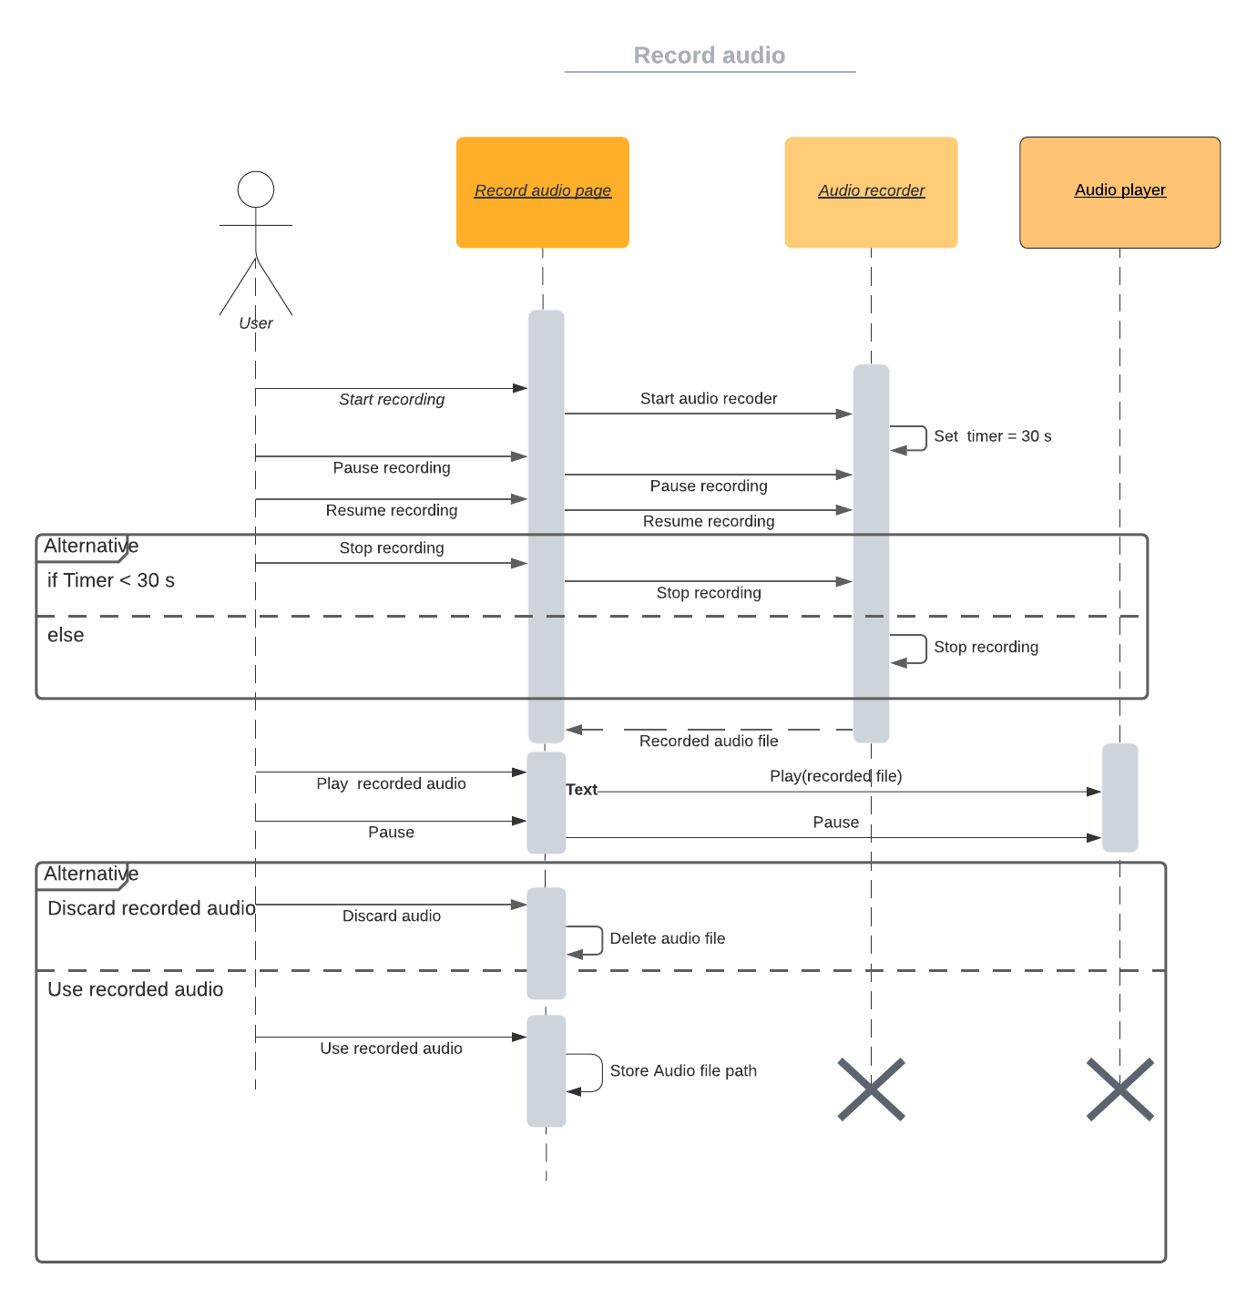
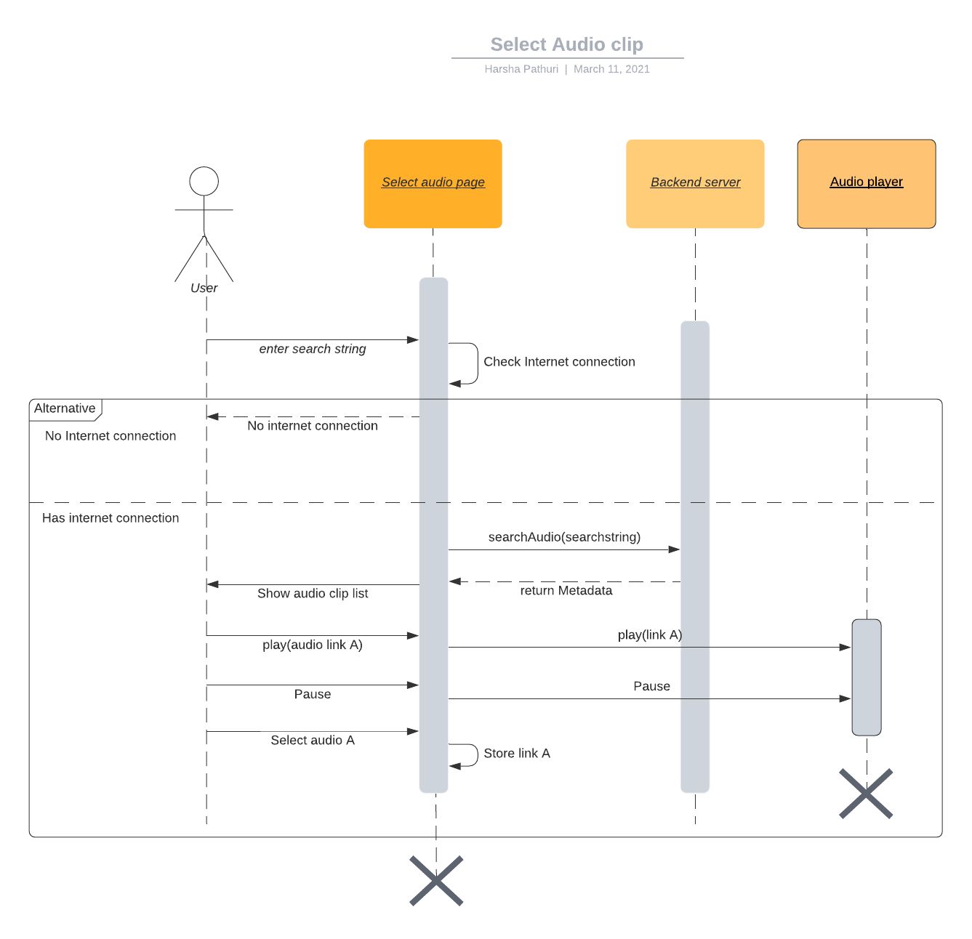
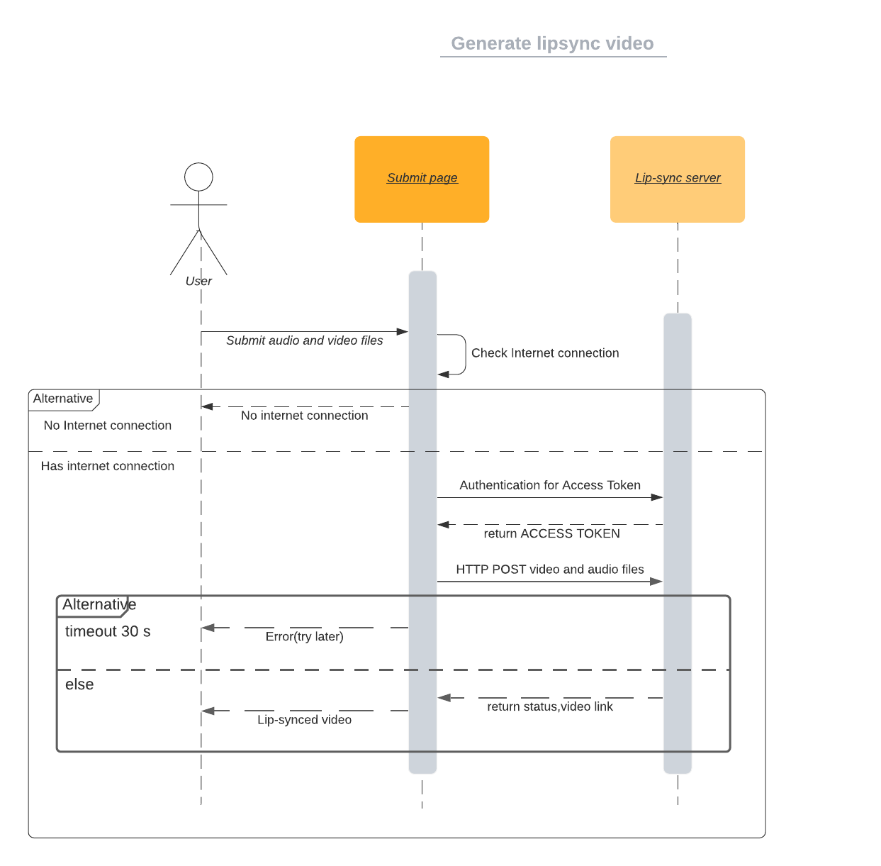
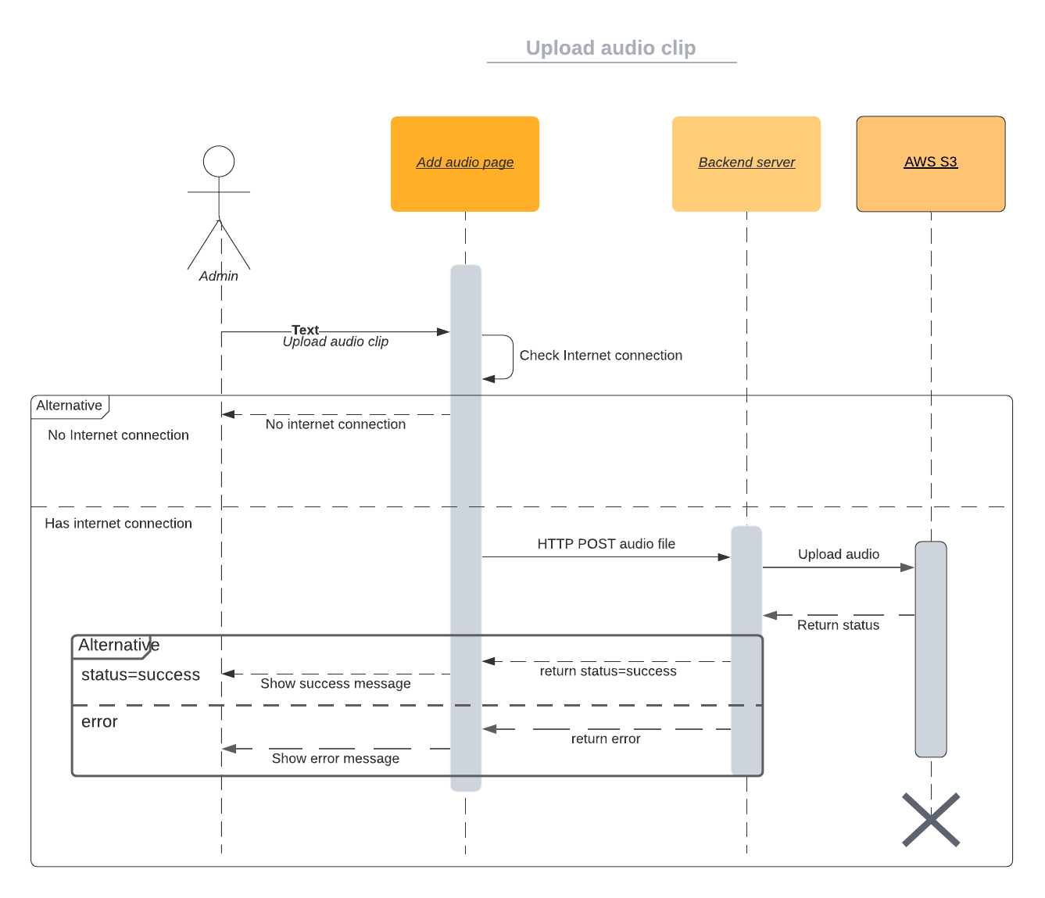

Design Rationale
- Initially, we were asked to make filters in Snapchat and Instagram, but we cannot get data from Instagram/Snapchat to the lip-sync server as both don’t support network modules. So, we chose an alternative to make an application that can make a lip-sync video and can share it with Instagram and Snapchat. We were advised to make the app in flutter as it can support cross-platform (android and iOS).
- At first, we thought of using firestore as our database, since it is built as a support to flutter but later shifted to AWS S3 as maintaining the firestore database is expensive compared to AWS.
- For interacting with AWS S3 we used amplify at first but shifted to backend server to interact with AWS S3, since amplify is still in beta state and have quite a few issues needed to be addressed.
- We used the native camera application of the mobile to record a video instead of implementing own camera as it may lead to poor resolution, and the native camera gives better support as it is integrated into the operating system and provides video with an aspect ratio similar to the screen of that particular mobile which is challenging to implement.

